Reconstruction of Earthquake Damaged Rural Houses (REDRH)

The Reconstruction of Earthquake Damaged Rural Houses (REDRH) project aims at reconstructing 7,972 houses damaged during the 18th Sept, 2011 earthquake. The unit cost is Rs 4.89 lakh per house with a total central allocation of Rs 391 crore over a period of three financial years 2011-12, 2012-13 and 2013-14. This project is fully funded under the Prime Minister’s Special Relief Package from the Planning Commission, Government of India.

- Deliverables
- Construction of 7,972 rural houses with earthquake resistant features.
- Completing the house construction without compromising on the design, construction quality, budgetary ceiling and time frame
- Following a transparent, fair and non-arbitrary process

- Why many traditional houses got damaged?
- Assessment of damage: 54,000 of the total 92,000 rural houses suffered various degrees of damage, but very few casualties.
- SWOT analysis: Superstructure of wooden framed houses with ekra walling and light iron sheet roof was mostly intact. But, the stone masonry load-bearing walls laid on mud-mortar and not having any reinforcement suffered maximum damage to the shear forces. Private houses with RC-frame structure with brick masonry infill and iron-sheet roof performed well, showing only non-structural damage.

Stone masonry load bearing walls suffered maximum damage
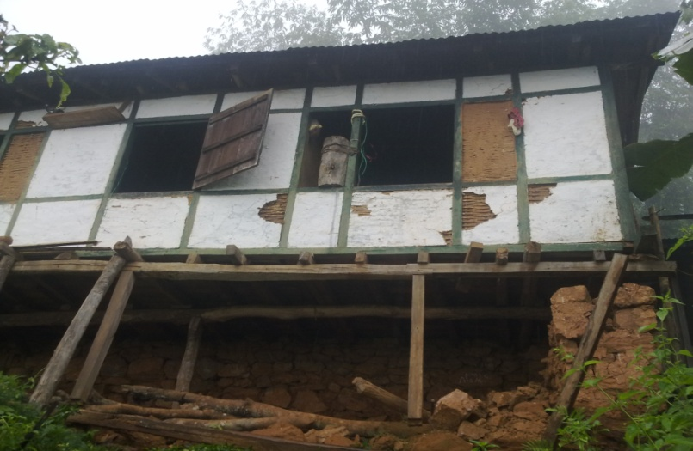

Stone masonry load bearing walls suffered maximum damage
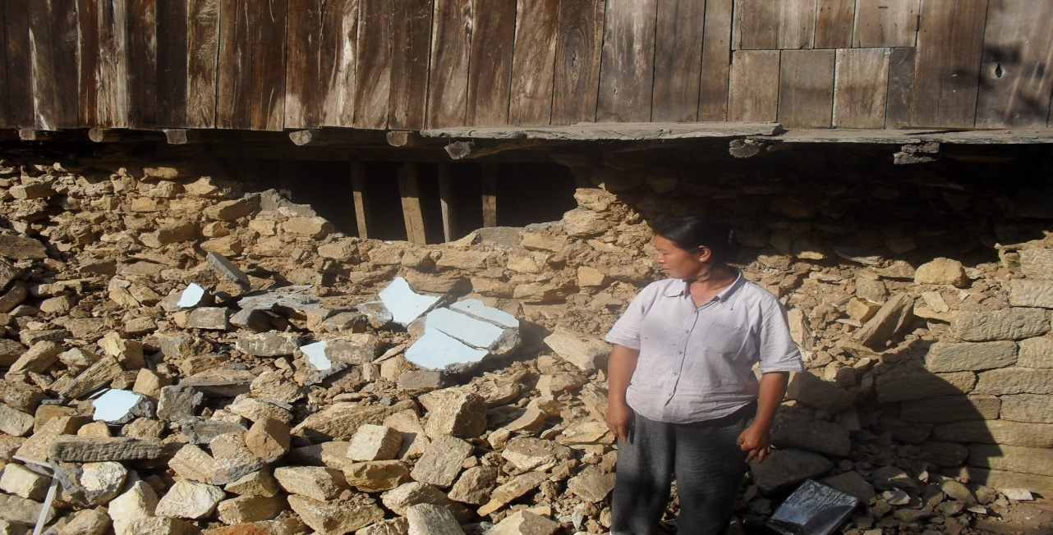

Non structural damage to RC frame houses
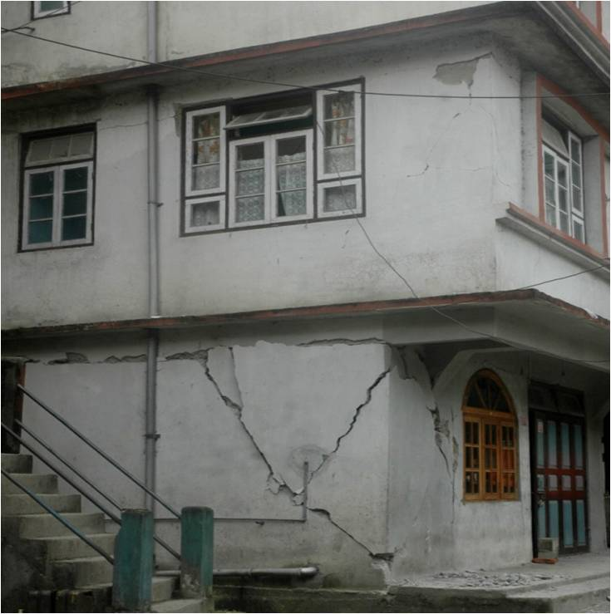
- How to make the new houses earthquake resistant?
- Earthquake resistant design: RC frame structure with 9 columns, plinth beam, roof beam and sill beam.
- Use of quality building material: Cement and 500D TMT bars of prescribed brands only to be used.
- Good workmanship: Simplifying the technical aspects by preparing easy to use IEC materials with adequate supervision by technical staff
- Concurrent monitoring: Regular and concurrent monitoring of the houses under construction

- Salient features of the house
- The design of the house will be RCC frame with a slab roof and having a plinth area of 605 square feet. However, in few remote areas, option of CGI roofing will be provided.
- Size: Total floor area should not be less than 605 sq feet
- Foundation: RCC with 9 columns (1feet x 1 feet) and RCC beams of (1feet x 1 feet)
- Walls: should be half brick walling over RCC frame
- Flooring: should be Cement Concrete
- Roofing: RCC Slab 4 inches thick
- Sanitation: Minimum one toilet along with septic tank

Top view of house
4 Rooms including two bedrooms, one dining –cum- kitchen and one bathroom

- Super-structure of house
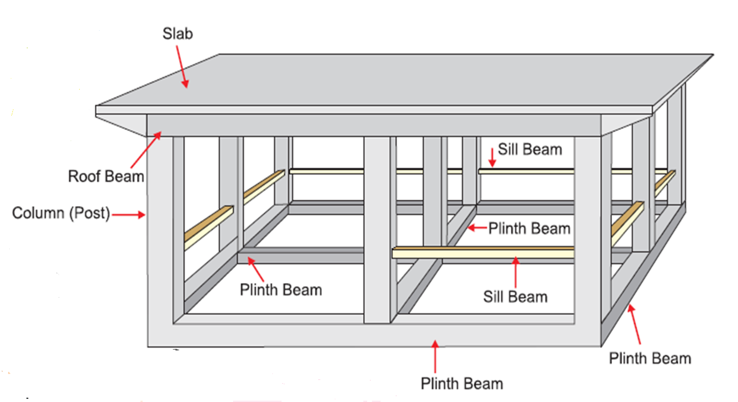

- Stages of progress
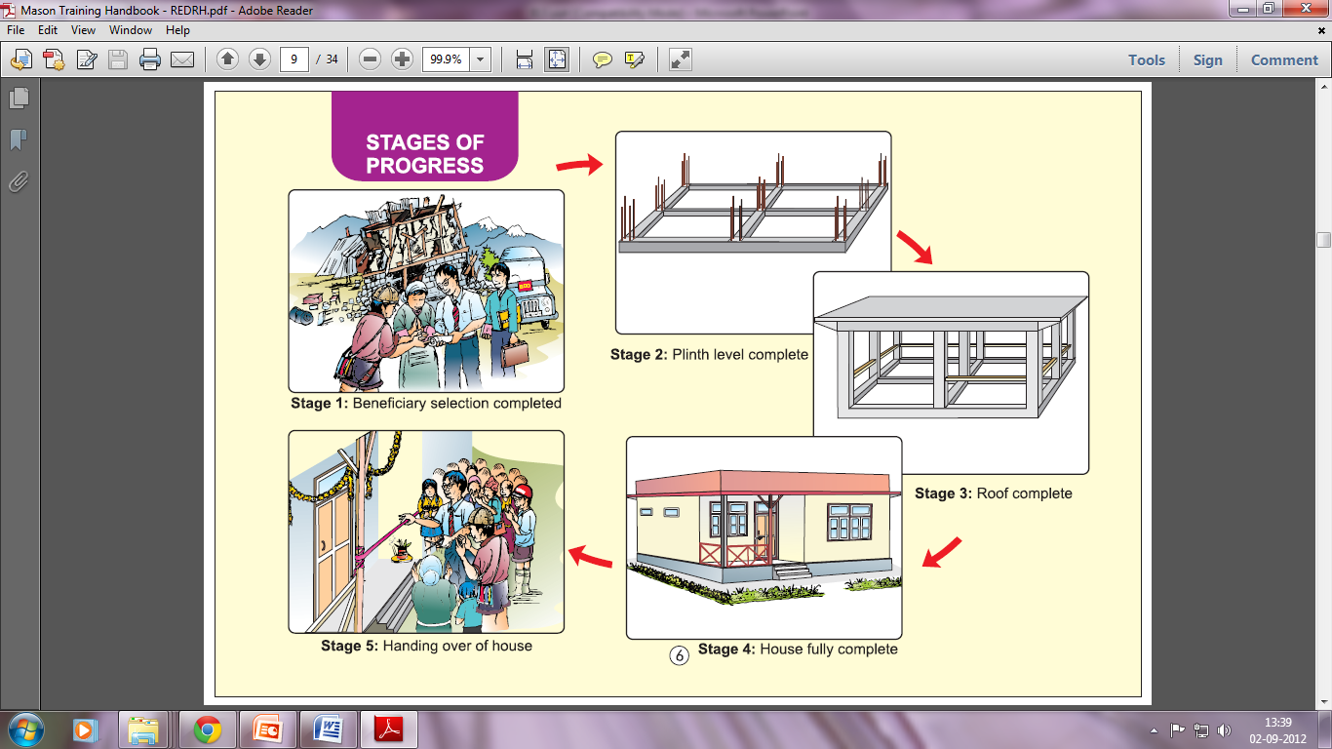

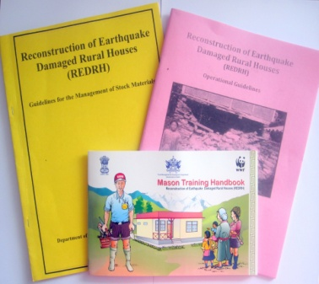
- Preparing the operational framework
- Operational Guidelines (47 pages) framed for the project
- Cabinet approval on the operational part of the project obtained
- Guidelines for management of Block Level Stores framed
- Guidelines for Joint Implementation Model framed
- Inspection report format of State Level Monitors notified

Mason Training Handbook (English and Nepali)

- Progress Update
- 3,000 houses are under various stages of construction with 1,000 houses slated for completion by March-April 2013.
- A total of Rs 120 crore out of the total Rs 391 crore outlay has been utilized so far

- Monitoring and evaluation
- Special Monitors: 29 senior officers from the Govt of Sikkim of the rank of Special Secretary have been assigned the task of monitoring each Block along with 29 supporting officers
- District Level Monitoring: By District Level Committee headed by the District Collector
- Web based MIS: With the support from the Department of IT, a web-based MIS <www.sikkimrmdd.gov.in> has been developed inhouse with a backend database which has modules like beneficiary selection, physical progress and e-stores.

